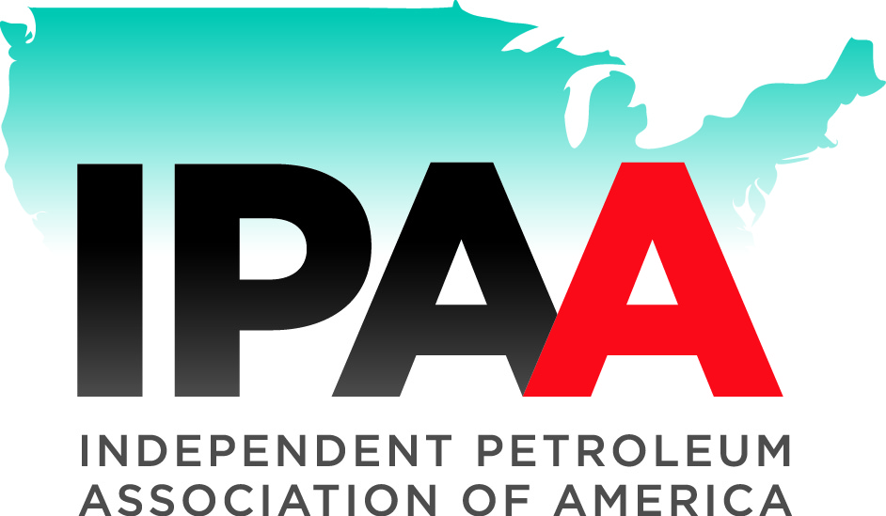  IPAA  1201 15th Street NW, Suite 300  Washington, DC 20005  Phone: 202.857.4722  www.ipaa.org | API  1220 L Street NW  Washington DC, 20005  Phone: 202.682.8000  www.api.org

March 2, 2015
Public Comments Processing
Attn: [FWS-R3-ES-2014-0056]
U.S. Fish and Wildlife Service Headquarters
MS: BPHC, 5275
Leesburg Pike
Falls Church, VA 22041-3803

Tony Sullins, Chief of Endangered Species
U.S. Fish and Wildlife Service Midwest Region
5600 American Blvd. West, Suite 990,
Bloomington, MN 55437

Re: Docket No. FWS-R3-ES-2014-0056

The following comments are provided on behalf of the American Petroleum Institute and the Independent Petroleum Association of America in response to request for comment on the status of the Monarch Butterfly (79 FR 78775, Volume 79, Number 250).
American Petroleum Institute (API)
API is a national trade association representing over 625 member companies involved in all aspects of the oil and natural gas industry. API’s members include producers, refiners, suppliers, pipeline operators, and marine transporters, as well as service and supply companies that support all segments of the industry. API and its members are dedicated to meeting environmental requirements, while economically developing and supplying energy resources for consumers.
Independent Petroleum Association of America (IPAA)
The Independent Petroleum Association of America (IPAA) is the national association representing the thousands of independent crude oil and natural gas explorer/producers in the United States. It also operates in close cooperation with 44 unaffiliated independent national, state and regional associations, which together represent thousands of royalty owners and the companies which provide services and supplies to the domestic industry. IPAA is dedicated to ensuring a strong, viable domestic oil and natural gas industry, recognizing that an adequate and secure supply of energy is essential to the national economy.
Comments
In general, API and IPAA do not possess specific scientific and commercial data and other information to respond to the specific requests in the referenced notice. However, a review of information about the species available to our organizations indicates the following:
No evidence exists in the literature of adverse effects from oil and gas industry operations on the species itself or on the destruction, modification, or curtailment of the species’ habitat or range.
Vectors identified as having a possible effect on the species at a population level include: parasites and disease; Bt toxins, present in corn pollen and anthers; pesticide and herbicide use in some areas of cultivation; predation; habitat alteration from deforesting of certain areas where the species overwinters in Mexico, select tree loss in California, and the use of glyphosate herbicides. None of these vectors is associated with oil and gas exploration and production.
The petition to the Service to list the Monarch Butterfly as a threatened species states that “In the broadest sense, monarch habitat is defined by the distribution of suitable species of milkweeds and their abundance and condition.” This is described as important to the species because milkweeds contain species-specific suites of toxic secondary compounds, including cardiac glycosides such as cardenolides, and various alkaloids, that are used for defense against herbivores. This petition explores the significance of loss of areas where milkweed is found in an extensive discussion that runs for several pages. There is no relationship identified in the literature between oil and gas activities and loss of milkweed habitat.
No assertion is made in the petition that establishes a relationship between oil and gas exploration and production activities and Monarch Butterfly populations. No such relationship is described in the literature to the extent that API and IPAA have been able to determine. Accordingly, if, at the conclusion of appropriate review, the species is listed, a 4(d) rule should be written to exempt or exclude the activities of the oil and gas industry from the prohibition against incidental take.
Thank you for considering this letter in your status review of the Monarch Butterfly. If you have any questions, please do not hesitate to contact the undersigned.

Respectfully submitted,

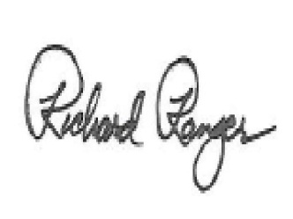  Richard Ranger  Senior Policy Advisor  American Petroleum Institute | 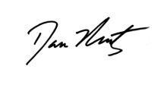  Dan Naatz  Senior Vice President of Government Relations and Political Affairs  Independent Petroleum Association of America

